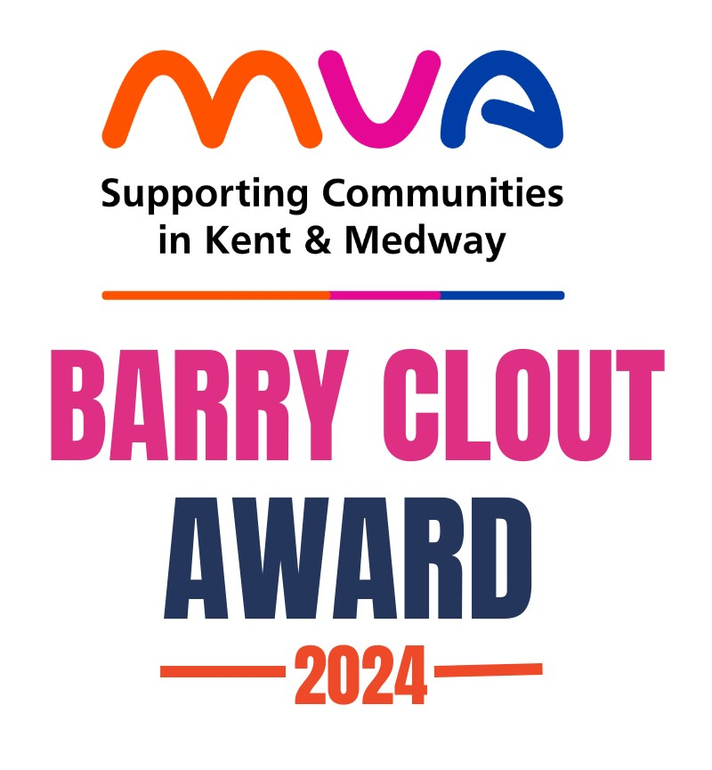
MVA’s 2024 Barry Clout Award for Outstanding Contributions to
Volunteering in Medway Nomination Form.

Celebrating those who help others in the Community﻿.

MVA are now inviting nominations for their 2024 Barry Clout Award.

The award is presented annually in memory of Barry Clout, an MVA Trustee and longstanding supporter of the Voluntary Sector, to recognise an individual who has given up their time, energy and skills to help others in the community across the Medway Towns.

The Outstanding Volunteering Contribution Award recognises volunteers whose selfless dedication and tireless efforts have made a profound impact on their communities.

If you would like to say a ‘BIG THANK YOU’ on behalf of the people of Medway, then please take a few minutes of your time to nominate them for this award by completing this form.

The closing date for all nominations is 12pm Monday the 7th of October 2024, with winners being presented with their award by Dr Gillian Fargher the High Sheriff of Kent, at MVA's AGM on Thursday the 7th of November.

About you:
Name
Email
Phone
Organisation Name
Organisation Address
About the person you are nominating:
Name
Email
Phone
Organisation Name (where they volunteer)
Organisation Address (where they volunteer)

Your Nomination
When making your nomination please consider and share about the nominee: the level of commitment shown, any achievements / outcomes, any barriers or challenges they have had to face and the overall impact they have had within the voluntary and community sector.
Why do you think they merit an award? Please give concise details of nominee’s service and involvement and examples of the nominee’s voluntary commitments. (Maximum of 250 words)

What has been the impact or benefit of the nominee on your Organisation and / or the local community? Please give concise details of the impact and/or benefit. (Maximum of 150 words).

If you have any questions about the 2024 awards please contact Lisa at MVA on 01634 812 850. Please return this form to MVA Barry Clout Awards, 5a New Road Avenue, Chatham, ME4 6BB or by e-mail volunteering@mva.org.uk.

